**Assignment 1**

|  |
| --- |
| **NAME: Deeksha kumari S**  **TEAM ID: PNT2022TMID30034** |

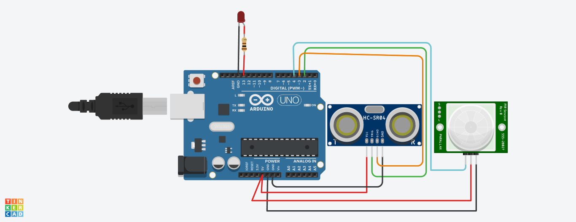

**Program:**

int t=2;

int e=3;

void setup()

{

Serial.begin(9600);

pinMode(t,OUTPUT);

pinMode(e,INPUT);

pinMode(4,INPUT);

pinMode(13,OUTPUT);

}

void loop()

{

digitalWrite(t,LOW);

digitalWrite(t,HIGH);

delayMicroseconds(1000);

digitalWrite(t,LOW);

float dur=pulseIn(e,HIGH);

float dis=(dur*0.0343)/2;

if(dis<=200){

Serial.print("Door Open");

delay(1000);

}

int p=digitalRead(4);

if(p==1)

{

digitalWrite(13,HIGH);

Serial.println("Motion detected");

delay(1000);

}

else

{

digitalWrite(13,LOW);

Serial.println("Motion not detected");

delay(1000);

}

}

**Output:**

Door OpenMotion not detected

Door OpenMotion not detected

Door OpenMotion not detected

Door OpenMotion not detected

Door OpenMotion not detected

Door OpenMotion not detected

Door OpenMotion not detected

Door OpenMotion not detected

Door OpenMotion not detected

Door OpenMotion not detected

Door OpenMotion not detected

Door OpenMotion not detected

Door OpenMotion not detected

Door OpenMotion not detected

Door OpenMotion not detected

Door OpenMotion not detected

Door OpenMotion not detected

Door OpenMotion not detected

Door OpenMotion not detected

Door OpenMotion not detected

Door OpenMotion not detected

Door OpenMotion not detected

Door OpenMotion not detected

Door OpenMotion not detected

Door OpenMotion not detected